The Pyramid of SUCCESS
Every success begins with a good foundation

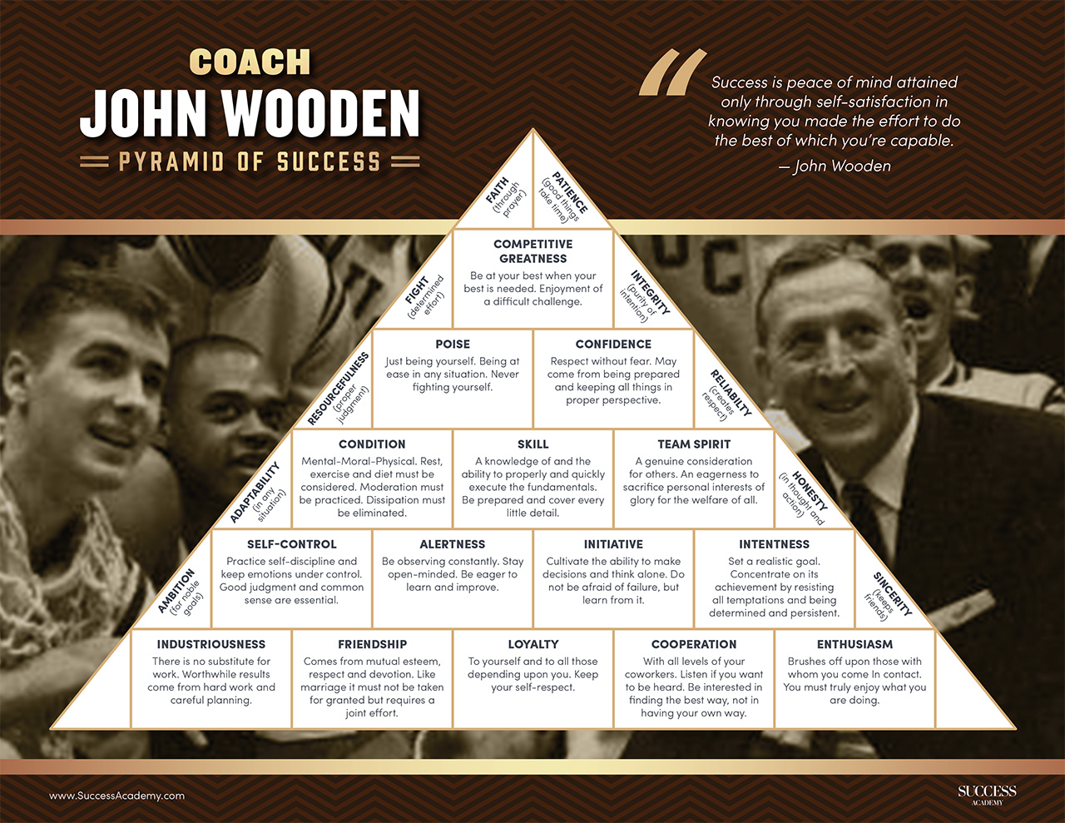

Coach Wooden’s greatest accomplishments were not limited to basketball.
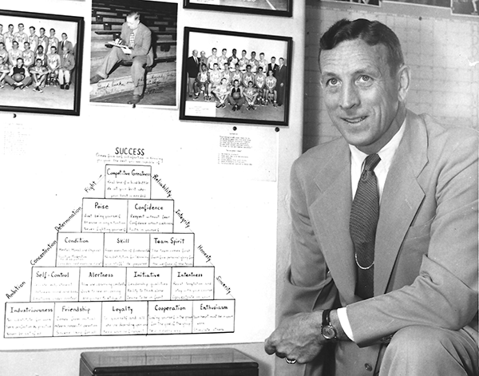

He brought an entire community together, inspired them with championships, and taught them how to master the fundamental skills that turn any dream into reality. The gyms he coached in became chapels, the court a pulpit where he preached a different kind of success approach.

Wooden spent decades identifying the characteristics and traits that help define a successful person and narrowed the list to 25 common behaviors. By 1948, he created the iconic triangular diagram and named it the “Pyramid of Success.”

When Coach Wooden introduced the world to the Pyramid of Success, he offered us all a roadmap for individual and team excellence—the same roadmap he used to build a legacy unmatched in the game of basketball.

The life principles summarized in the Pyramid of Success had no explicit reference to basketball or athletics. The coach’s diagram was simply a roadmap to being a better person.

Make each day your masterpiece with Coach Wooden’s timeless wisdom
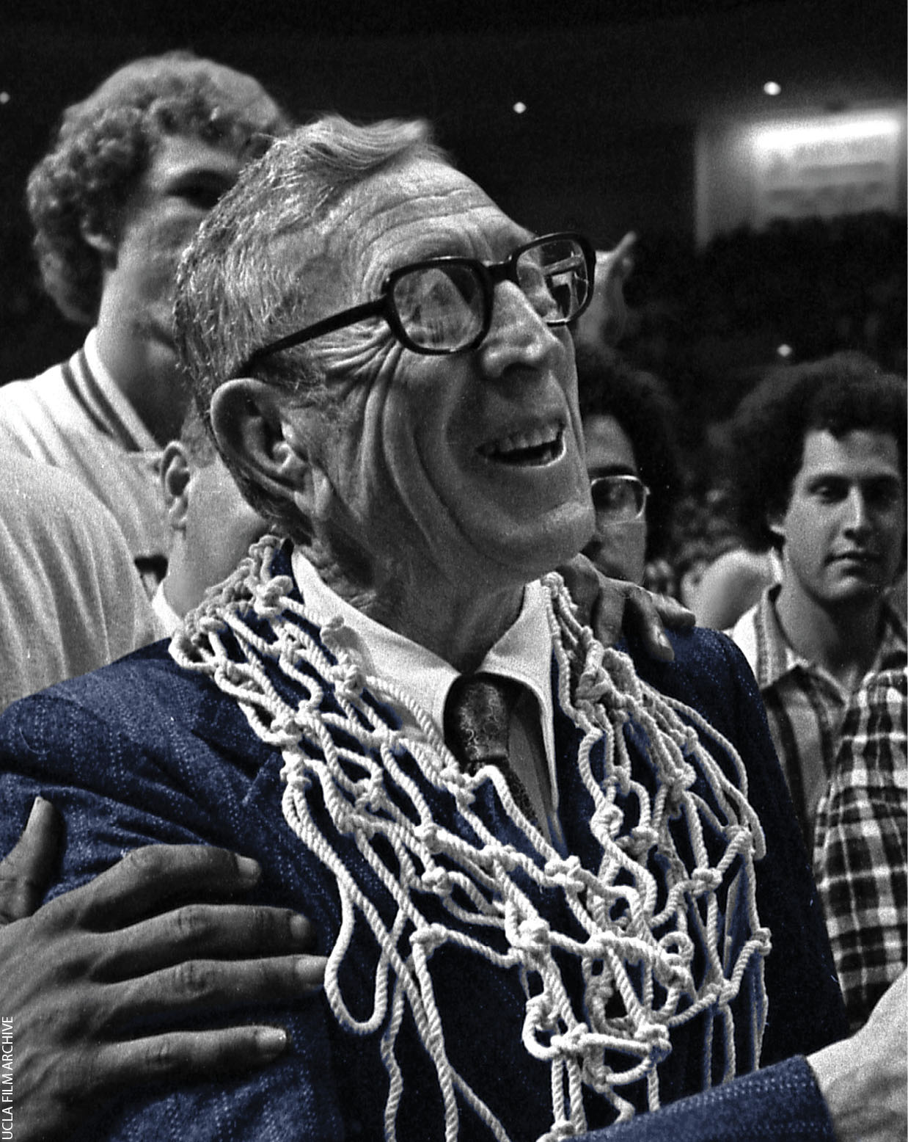
Follow the on- and off-the-court lessons that Wooden shared with his students:
- Rethink the meaning of success and find a more simple approach to living a meaningful and fruitful life
- Gain firsthand insights into what it really takes to build a championship team by rediscovering the timeless principles of lasting achievement
- Walk through Coach Wooden’s tested Pyramid of Success framework that has been responsible for creating more champions, building more companies, and changing the lives of its followers than perhaps any other success plan ever
- Experience a philosophy for living that pushes against the “shiny object syndrome” of today’s success world and focuses instead on simply doing simple things
- Find out what made Coach John Wooden such a powerful influencer from the very people he mentored one-on-one in his now famous den
- Discover a new way of building self-control — that champion’s discipline — by following Coach Wooden’s humble teachings
- Unlock the ability to confidently walk through life and pursue your dreams and goals knowing your efforts are supported by a solid, proven framework for achievement

The building blocks of Wooden’s Pyramid of Success

Industriousness
There is no substitute for work. Worthwhile results come from hard work and careful planning.

Loyalty
To yourself and to all those depending upon you. Keep your self-respect.

Alertness
Be observing constantly. Stay open-minded. Be eager to learn and improve.

Initiative
Cultivate the ability to make decisions and think alone. Do not be afraid of failure, but learn from it.

Enthusiasm
Brushes off upon those with whom you come in contact. You must truly enjoy what you are doing.

Self-Control
Practice self-discipline and keep emotions under control. Good judgment and common sense are essential.

Friendship
Comes from mutual esteem, respect and devotion. Like marriage, it must not be taken for granted but requires joint effort.

Cooperation
With all levels of your co-workers. Listen if you want to be heard. Be interested in finding the best way, not in having your own way.

Intentness
Set a realistic goal. Concentrate on its achievement by resisting all temptations and being determined and persistent.

Confidence
Respect without fear. May come from being prepared and keeping all things in proper perspective.

Skill
A knowledge of and the ability to properly and quickly execute the fundamentals. Be prepared and cover every little detail.

Team-Spirit
A genuine consideration for others. An eagerness to sacrifice personal interests of glory for the welfare of all.

Poise
Just being yourself. Being at ease in any situation. Never fighting yourself.

Condition
Mental-Moral-Physical. Rest, exercise and diet must be considered. Moderation must be practiced. Dissipation must be eliminated.

Competitive Greatness
Be at your best when your best is needed. Enjoyment of a difficult challenge.

